Visitor Management Design Document

DRAFT

|  |  |  |  |
| --- | --- | --- | --- |
| Date | Version | Author | Status |
| 07/09/16 | 0.1 | Kingsley Agbo | Active |
|  |  |  |  |
|  |  |  |  |

|  |  |  |  |
| --- | --- | --- | --- |
| **Version** | **Date** | **Author** | **Amendments** |
| 1.0 | 07/09/16 | Kingsley Agbo | Creation, Initial draft for review |
| 1.1 | 27/10/16 | Kingsley Agbo | Updating document with new requirements |
| 1.2 | 28/10/16 | Ruth Awojobi | Updating document with new requirements and amending previous contradicting requirements |
| **1.3** | **15/11/16** | **Ruth Awojobi** | **Removing old user stories and writing spec** |
| **1.4** | **20/11/16** | **Ruth Awojobi** | **Completion of initial draft spec** |

|  |  |  |  |
| --- | --- | --- | --- |
| **Version** | **Date** | **Reviewed by** | **Comments** |
|  |  |  |  |
|  |  |  |  |
|  |  |  |  |

|  |  |  |
| --- | --- | --- |
| **Version** | **Date** | **Outstanding Issues** |
|  |  |  |
|  |  |  |
|  |  |  |

|  |  |  |
| --- | --- | --- |
| **Name** | **Date** | **Sign Off** |
|  |  |  |
|  |  |  |
|  |  |  |
|  |  |  |

Contents

1.0 Introduction 5

1.1 Purpose 5

1.2 Scope 5

1.3 Definitions and Abbreviations 5

1.4 Circulation 5

1.5 Assumptions 5

1.6 Risks 6

1.7 Dependencies 6

2.0 Web Application Functionality and Design 7

2.1 Administration 7

2.1.1 Overview 7

2.1.2 Functional Requirements 7

2.2 Check In 8

2.2.1 Overview 8

2.2.2 Functional Requirements 8

2.3 Check Out 14

2.3.1 Overview 14

2.3.2 Functional Requirements 14

2.4 Registration 15

2.4.1 Overview 15

2.4.2 Functional Requirements 15

2.5 Kiosk 15

2.5.1 Overview 16

2.5.2 Functional Requirements 16

3.0 Design Screens 17

4.0 Application wide Specifications 21

5.0 User Journey 21

21

6.0 Data Model 21

7.0 Process Flow 22

7.0 Appendix 23

# 1.0 Introduction

Having a system that allows the management of visitors, is an essential tool for any forward thinking organisation. Not only because this is crucial in monitoring and managing access but also because it presents a professional side to the business even from the onset. Allowing visitors to have a positive attitude and experience while visiting an organisation especially for the first time.

## 1.1 Purpose

The aim of this Visitor Management Design Document is to provide a requirement document which will be used in the development of the intended Visitor Management web Application by an offshore development team.

This design document is to serve as the only piece of documentation that describes the functional requirements in the form of User Stories (US) and UI design screens, for the development of the Application. Attached to every US is a set of Acceptance Criteria (AC) that will form the basis for UAT and sign off of that particular US. A UI/UX design will be included to convey the desired look and feel of what is to be built. Process flows, data structures, user journey/ screen navigations and workflow information will also be provided where required to assist the offshore team in their work.

## 1.2 Scope

The scope of this document is to initially build a visitor management and check-in application that allows easy access self-check-in /out, one touch badge printing ID and photo capture. In the first instance, development will look to fulfil the phase 1 core requirements and a decision would be made as to when to proceed with subsequent phases - [Phase 2/ 3](https://fsifm.sharepoint.com/Enterprise FM/Shared Documents/Web Applications/Visitor Management/Requirements/Visitor Management User Stories.xlsx).

## 1.3 Definitions and Abbreviations

* US – refers to User Story
* AC – refers to Acceptance Criteria
* EFM – refers to Enterprise FM team
* KG – refers to Knowledge Group
* Dreamscape – this is the platform upon which all web applications will be built

## 1.4 Circulation

* EFM and KG team members
* Any changes, update or amendments made to this document must be circulated to the author and agreed with the Lead representative from the KG in this case it is Paul Palmer
* This document is the only living document for the duration of the project so requirements contained herein may change to meet business needs.

## 1.5 Assumptions

* The integration with access control and integration with ANPR will not be implemented at the first instance (Phase 1).
* The product that would be delivered will fulfil all of the phase 1 core requirements except where stated and will be fit for purpose.
* Those requirements that may need a spike to ascertain if they would be achieved within this phase or not, would be regarded as unachievable for phase 1 until the spike has been concluded.
* That the phase 1 Visitor Management application is expected to be a stand-alone application and would not be dependent on any other back-end system

## 1.6 Risks

* This web application will be built by a new offshore team who are still developing their knowledge of the platform. This may impact the deliverables and delivery time for this project as they will require additional support during the development phase of this project.
* As the Dreamscape Platform would be used to build this Application, it should be noted that not all the functionalities that are requested, may be readily achievable based on the limitations of the platform. Where this is the case, a spike will be initiated to provide an estimate and a suitable work around.
* All requirements that cannot be included in this phase (Phase 1), would be estimated and included in the next phases (Phases 2/ 3).
* Encountering bugs and blockers in the Dreamscape Platform may cause delays in delivering this project on time.

## 1.7 Dependencies

None for phase 1

# 2.0 Web Application Functionality and Design

# 2.1 Administration

## 2.1.1 Overview

The Administration feature within the application is designed specifically for the system admin to be able to configure and set up the application. Also here, the administrator will be able to create and manage Person and Booking records.

## 2.1.2 Functional Requirements

|  |  |  |  |  |  |
| --- | --- | --- | --- | --- | --- |
| **US-ID** | **Theme** | **As a/an** | **I want to…** | **So that…** | **Acceptance criteria** |
| 001 | Administration | Admin | Be able to use the app from any device | I don't need to logon to a specific workstation or type of device to be able to use the app | * Mobile/Web  Android/iOS/Windows |
| 002 | Administration: Setting Screens (Terms and Conditions) | Admin | Specify the contents for a disclaimer or terms & conditions | This can be displayed prior to kiosk check-in, and we record that the visitor has accepted the terms | Simple text box |
| 003 | Administration:  Setting Screens (Terms and Conditions) | Admin | Enable/disable the disclaimer or terms & conditions | I can choose whether or not to display the disclaimer or terms & conditions on the kiosks | Toggle on/off |
| 004 | Administration:  Setting Screens (Photo ID) | Admin | Specify if photos are mandatory for visitors | Visitors are prompted for a photo at check-in if one doesn't exist | Toggle on/off |
| 005 | Administration: Setting Screens (Photo ID) | Admin | Specify if capturing ID is mandatory for visitors | Visitors are prompted for ID at check-in if it doesn't exist | Toggle on/off |
| 006 | Administration: System Settings (Attribute Type) | Admin | Maintain a list of attributes that can be assigned to a booking | Specific requirements can be added or removed easily, and to record (and report on) additional information required by our own business processes | Attributes list to include:  *WIFI  *Disabled Access  *Escort Required  *VIP  *Special Dietary Requirements  Be able to capture in a **set up**:  *Attribute Type/Title  *Attribute Description  That would allow additional notes with bookings e.g escort needed, disabled parking needed  **\*User should not be able to delete attribute type if already in use** |
| 007 | Administration: Setting Screens (Booking Type) | Admin | Show/Hide the booking types available within the system | Only booking types that are appropriate to my business can be used | * Settings screen that lists the 3 booking types, and a hide/show toggle against each.  *Able to hide/show: 1. Visit 2. Event 3. Employee |
| 008 | Administration: Setting Screens (Person Type) | Admin | Show/Hide the Person types available within the system | Only Person types that are appropriate to my business can be used | * Settings screen that lists 3 of the 4 person types, and a hide/show toggle against each. Do not allow person type of Host to be hidden as this will always be required.  *Able to hide/show:  1. Visitor 2. Event Attendee 3. Employee |
| 009 | Administration: Create New Booking | Host | Choose my name from a list of hosts | I don't need to register separately to my existing domain logon | *Manually add/amend/delete host records individually and/or allow mass import from Active Directory (AD)  *Able to link each host record to an AD account to allow contact details to be pulled through, instead of needing to maintain separately |
| 010 | Administration: Add Person | User | Using ‘Person Type’ to keep visitors, staff & attendee lists separate from each other | Visitor is not accidentally selected as the booker, and vice versa | *Separate lists, feeding separate dropdowns |
| 011 | Administration: Edit Person | User | Store a history of all visits against a single visitor record | The visitor record can be reused each time with just the latest visit details appended | *One visitor record linked to many visit records.  *Allow a history of visits to be accessible per visitor (Save having to re-enter visitor information when they're a returning visitor)  Fields to include:  *Host Organisation  *Booking Dates  *Arrived  *Departed  *Host name |
| 012 | Administration: People List | Admin | View all people in a grid view | I can see & search all visitors, past & present | Avatar (Scaled from photo)  Name  Company Phone  Email |
| 013 | Administration:  Check-in | User | Have real-time access to a list of today's expected visitors | I know who today's expected visitors are | *Built-in report for all visitors where visit date is today *(visual display in a grid)*  * Fields to include:  *Visitor Name  *Host name  *Start time  *Status  *Date  *Location  *Accessibility warning indicator |
| 014 | Administration:  Booking | User | Ability to update/ amend a booking after its initial creation | Changes can be made as required, and notifications sent to visitors/attendees accordingly | * On the booking page, user selects ‘Amend Booking’ and is directed to the ‘Edit Booking’ page.  Here, user is able to amend the following fields:  * Date  * Time  * Location  * Visitors/Attendees  *Email notification to be sent to user  **\* See VM:013 in APPENDIX for specimen email** |
| 015 | Administration: External System | Visitor | Receive a notification when a visit or event I'm booked onto is amended or cancelled | I receive the latest information regarding the booking and any changes I may need to be aware of | **\* See VM:013 or VM:014 in APPENDIX for specimen email**  *Email notification to be sent once  Fields to capture for Amendment includes:  * Change of date  * Change of time  * Change of location  Fields to capture for Cancellation includes:  *Previous Visit Date  *Previous Visit Time  *Previous Visit Location  *Host Name  *Cancellation Reason  *Cancelled By |
| 016 | Administration  (SPIKE AGREED) | Host/ User | Mass-print visitor badges without checking the visitors in | I can pre-emptively print a batch of badges ahead of the expected arrival of a large group | *Be able to bulk print badges without changing visitor status, e.g. for events where badges need to be placed for easy collection  *Be able to send multiple visitor records to the printer at the same time to print their badges |
| 017 | Administration: Check-out | Host/ User | Have immediate, mobile access to a list of all current visitors | In the event of an emergency, I don't endanger myself or others by running & printing a report | *Be able to at a glance tell how many visitors are in a location or have arrived for an event  Fields to capture includes:  *Visitor Names  *Host Organisation  *Arrival Time  *Host Name |

# 2.2 Check In

## 2.2.1 Overview

The Check-in feature allows the receptionist to complete the booking process of visitors and event attendees who have been booked for a visit or to attend an event. At check-In, depending on what option is chosen, the user will have to provide their name or unique booking code to identify them self. The booking code will normally be provided at the time of booking and also included in the confirmation email to user. The receptionist can also capture a photo of guests if required and print badges for use.

## 2.2.2 Functional Requirements

|  |  |  |  |  |  |
| --- | --- | --- | --- | --- | --- |
| **us-ID** | **Theme** | **As a/ an** | **I want to…** | **So that…** | **Acceptance criteria** |
| 001 | Check In: | Receptionist | Check visitors in from a fixed reception desk when they arrive | Visitors have a clear, single point of check-in to approach on arrival | *Visitors can be checked in via check-in screen or booking screen  Fields to capture within check-in screen includes:  *Visitor Name  *Host Name  *Host Organisation  *Expected Arrival Time  *Check-in Icon to capture time stamp of actual arrival (Status changes in DO from booked to arrived)  *Option to print badge |
| 002 | Check In | Receptionist | Conduct roaming check-ins using a tablet device | I can be roaming within an open space and approach visitors to check them in, to save them needing to approach reception and to triage people within the queue during peak times | * Mobile interface to check visitors in on their behalf  *Visitors can be checked in via check-in screen or booking screen |
| 003 | Check In  (SPIKE AGREED) | Receptionist | Take a photo of the visitor on arrival | The visitor's photo can be added to their record and subsequently printed on their badge if desired | *Photo to be stored against the person's record.  Capture photo via:  * Standalone webcam (attached to desktop, laptop or kiosk)  * Integrated webcam (built into laptop or kiosk)  * Mobile device's built-in camera |
| 004 | Check In: External | Host | Receive a notification when the check-in process has been completed for/by my visitor or group of visitors | I know my visitor has arrived and where to greet my visitor(s) | Notification type to include any of this:  * Email  * SMS  * On screen pop-up notification  **\* See VM:021 in APPENDIX for specimen email** |
| 005 | Check In | Receptionist | Issue a visitor's pass on completion of check-in | Visitor has ID badge | *Badges can be printed in via check-in screen or booking screen  Badge to be issued by:  * Fixed reception desk  * Roaming reception staff  * Security/car park staff  * Kiosk  *Be able to print a Badge |
| 006 | Check In | Receptionist | Produce a visitor's badge as quickly as possible with as few clicks as possible | The visitor's check-in experience is more efficient | *Badges can be printed in via check-in screen or booking screen  *Automate the printing of a badge on completion of check-in  *Minimum of clicks/touches, e.g. touch "Arrived" and badge prints automatically |
| 007 | Check In | Receptionist | Check-in visitors from a searchable/sortable list view | I can quickly find visitors in the way that I find most intuitive | *Visitors will be searched for via the check-in screen  *Touch/click any heading to sort by it, e.g. Name, Host, Host Org, Date/Time |
| 008 | Check In | Receptionist | Automatically record the time when visitor arrives or departs based on when their status was updated | Times don't need to be recorded manually | *(An Audit trail within the application)*  *Multiple status history records linked to each visit record  i.e Arrived-when visitor arrives and time: Booked-when visitor has been booked and time: Checked In-when visitor has been checked In and time: Departed-when visitor has departed and time  *Automatic timestamp on each visit status change  *Actual Arrival Time  *Actual Departure Time |
| 009 | Check In | Receptionist | Create a booking for arrivals where no advanced booking had been made by a host | We have a record of the visit | **Follow the amend booking process** |
| 010 | Check In | Receptionist | Mark an event attendee as arrived with a single click | Large volumes of attendees can be processed quickly during peak times | * Achieved via booking page  *Able to Single-click arrive function on individual attendee record as against each attendee in list. |
| 011 | Check In  (SPIKE AGREED) | Receptionist | Check-in all OR some visitors for a single booking at once | Badges can be printed as a batch rather than individually | *Be able to bulk print badges without changing visitor status, e.g. for events where badges need to be placed for easy collection  *Be able to send multiple visitor records to the printer at the same time to print their badges |
| 012 | Check- in | User | Automatically update the visitor status based on what I'm doing (e.g. creating a booking, checking them in, cancelling, etc) | We can know which visitors have arrived, departed, etc, without having to manually update the status myself | "System to be preloaded with 4 Visitor Statuses:  1. Booked  2. Arrived  3. Departed  4. Cancelled  Prevent these from being amended or deleted. |

# 2.3 Check Out

## 2.3.1 Overview

The Check-out feature will provide the receptionist/ host the opportunity to be able to manually check-out guests after a visit or attending an event.

## 2.3.2 Functional Requirements

|  |  |  |  |  |  |
| --- | --- | --- | --- | --- | --- |
| **us-ID** | **Theme** | **As a/ an** | **I want to…** | **So that…** | **Acceptance criteria** |
| 001 | Check Out | Receptionist/ Host | Check-Out on behalf of my visitor | I can manually record check-Out time should they not check-Out as expected | *Once the Check-out icon is selected, the system captures check-out/departure time per visitor, per booking  *Actual Departure Time (if known)  *Auto update Status to departed |
| 002 | Check-Out | User | Have the available attendee spaces increase as attendees check-out | Additional attendees can be added to an event when a space becomes available  Available event spaces |  |

# 2.4 Registration

## 2.4.1 Overview

The registration feature allows users to create a booking in order to allow a person to visit or attend a scheduled meeting or event. After the creation of the booking the user will be able to register all visitor types using a person type form; which captures specific details depending on the type of visitor; linking them to that booking. Additional functionalities are included like the ability to allocate predefined attributes to visitor types, such as assigning VIP attributes to specific people and making them unsearchable by others.

## 2.4.2 Functional Requirements

|  |  |  |  |  |  |
| --- | --- | --- | --- | --- | --- |
| **us-ID** | **Theme** | **As a/ an** | **I want to…** | **So that…** | **Acceptance criteria** |
| 001 | Registration | User | Classify my visitor as a VIP | Their details do not appear on the self-serve kiosks to protect their identity from others | *Select VIP attribute within a person record  *VIP’s should NOT be searchable on the kiosk check in searches |
| 003 | Registration | User | Register a single visitor/attendee or a group of visitors/attendees via a single booking | The booking & check-in processes are expedited, and duplication is minimised, as I don't have to fill in the same form repeatedly for visitors/attendees who are part of a group | *Search bar on booking page  *Add attendee button |
| 004 | Registration | User | Select the host's organisation before selecting/typing the host name | The list of hosts is filtered by organisation | *Add Host Screen  *The list of hosts is filtered by organisation |
| 005 | Registration: External | User | Have my visitor bookings appear in my calendar automatically | I can plan ahead and receive timely reminders | *Be able to Integrate with:  * Microsoft Exchange Server  * Outlook.com  * Office 365  * Gmail |
| 006 | Registration | User | Start typing a visitor's name and be prompted with suggestions as I type each character | I can quickly find details of a returning visitor when making a booking and duplication is kept to a minimum | *Booking Page  *Be able to use an autocomplete function to quickly find a record of past visits  *Suggested matches to refresh with each keystroke (excluding VIPs ) |
| 007 | Registration | User | Select the host's organisation before selecting/typing the host’s name | The list of hosts is filtered by organisation | *Be able to create a host organisation in a **set up** so new hosts can be added |
| 008 | Registration | User | Record notes against a booking | I can see additional requirements for the visitor e.g. disabled access. | *Be able to capture additional notes as Free text on booking |
| 009 | Registration | User | Choose a person type for the person I'm entering into the system | The information gathered on the person is varied based on the person type | "System to be preloaded with 4 person types:  1. Visitor  2. Attendee  3. Employee  4. Host  Prevent these from being amended or deleted. |
| 010 | Registration | User | Choose a booking type for the booking I'm making | The information gathered for the booking is varied based on the type of booking | "System to be preloaded with 3 booking types:  1. Visit  2. Event  3. Employee  Prevent these from being amended or deleted. |
| 011 | Registration: External | User | Receive a confirmation when I've been booked as a visitor or event attendee | I receive relevant information regarding the booking | **\* See VM:042a and VM:042b in APPENDIX for specimen email**  Information to capture includes:  * Date of visit  * Time of visit  * Host name  * Address to visit  * Directions  * Map (Embedded or link)  Formats could include:  * Email  * SMS  **NOTE:** Information could be embedded, or as a URL to hosted information |
| 012 | Registration: External | User | Receive an Email confirmation when I complete a booking for a visitor or group of visitors | I have confidence that the booking process completed successfully | Confirmation in one of several formats. User to choose between:  * Email  **\* SMS (Not Achievable at the moment)**  * On screen pop-up notification |
| 013 | Registration | User | Allocate predefined attributes to a booking | Specific requirements are known when the visitor checks in, and to record (and report on) additional information required by our own business processes | e.g. WiFi, disabled access, escort required, VIP, special dietary requirements, etc |
| 014 | Registration | Host/User | Maintain visitor records | Visitor information is recorded just once, so that it can be linked to or from multiple bookings | *Person record  Fields to capture includes:  *Name  *Phone  *Email  *Company  Address  *Vehicle Registration  *  *Photo  *ID Capture  *Person Type |
| 015 | Registration | Host/User | Automatically generate an alphanumeric code per event attendee | Attendees can perform kiosk check-in using this unique code alone | *Be able to Auto-generate a code per attendee at time of booking  *Code to be completely unique  *Code not to be a sequence number to minimise others guessing someone else's code  *Code to be included in booking confirmation email to attendee. |
| 016 | Registration | Host/User | Search for a Host’s Company | when searching for a Host I am limited to only Hosts for that company | *Filter Host Name by Host Company *Only include Persons with Role of Host  *Both fields to be auto-complete |
| 017 | Registration | Host/User | Search for the Location for a Booking | I can reuse existing location records or add a new one | *Amend booking  Auto-complete field, with option to ‘Add New’ Location at the bottom of the list |
| 018 | Registration: External | Host/User | Be notified when the current capacity of users for a location has reached the maximum capacity for that location | I can stop the registration of new users for that particular location | *Notification by email to alert the user/host before current capacity =total capacity  *Visible display of the **Current** capacity and the **Total** capacity on the screen, so the host is aware of how many available spaces are left  *Admin to be able to set up a total capacity for a location |
| 019 | Registration | Host/User | Specify that my event is invite only | Walk-ups without a booking can't attend | Able to set a flag when creating an event record that specifies if the event is "Invitation Only" |

# 2.5 Kiosk

## 2.5.1 Overview

Kiosk will be designed to allow users to be able to self-check-In by searching for their names or by entering an auto generated code. Its design is expected to be simple for use by any type of user.

## 2.5.2 Functional Requirements

|  |  |  |  |  |  |
| --- | --- | --- | --- | --- | --- |
| **us-ID** | **Theme** | **As a/ an** | **I want to…** | **So that…** | **Acceptance criteria** |
| 001 | Kiosk | Admin | Display regulations or terms & conditions as part of the kiosk check-in process | Visitors must read/view & agree to any of our prerequisites | Information can be displayed in a number of formats, including:  * On screen text  * Documents  * PDF  * HTML  * Videos  User to agree to terms by touch accept or signing the screen  **Pre-condition: Settings are set to show T&C’s** |
| 002 | Kiosk | Visitor | Start the check-in process finding myself on the system by typing all or part of my name | I can check in as quickly as possible | * Once the user is identified in the kiosk, the kiosk will present a confirmation screen (a further level of identification to ensure user is performing the check-in process for the correct booking)  Suggested matches to refresh with each keystroke, but excluding:  * Those marked as VIP  * Those already arrived  * Those due on future dates  **Pre-condition: Settings are set to show end user’s ability to find by name** |
| 003 | Kiosk | Visitor | Find myself on the system by entering a code that has been sent to me in advance | I can check in as quickly as possible | *Unique reference code should have been sent to the visitor  *when code entered visitor details should be displayed  *visitor should be able to print badge  **Pre-condition: Settings are set to show end user’s ability to find by code** |
| 005 | Kiosk | Visitor | Check-in using intuitive, touch-screen software | The check-in process is as easy as possible and doesn't require any training or assistance | *A tool tip or help function should be available on every field as a guide for users |
| 007 | Kiosk | Visitor | Take a photo of the visitor on arrival | The visitor's photo can be added to their record and subsequently printed on their badge if desired | *Photo to be stored against the person's record.  Capture photo via:  * Standalone/Integrated webcam attached to kiosk  **Pre-condition: Settings are set to show photo is required** |
| 008 | Kiosk | Visitor | Take a photo of the visitor’s ID on arrival | The visitor's ID can be added to their record | *ID capture to be stored against the person's record.  Capture ID via:  * Standalone/Integrated webcam attached to kiosk  **Pre-condition: Settings are set to show photo is required** |
| 003 | Kiosk | Visitor | Start the check-out process finding myself on the system by typing all or part of my name | The system is aware I have left the building | * Allow selection from 4 smiley faces can gauge satisfaction levels overall  *Provide visitors the option of rating their satisfaction level when checking-out  * Once the user is identified in the kiosk, the kiosk will present a confirmation screen (a further level of identification to ensure user is performing the check-out process for the correct booking) |

# 3.0 Design Screens

(To be revisited based on ratification notes send on 21/11/16. RA to add some description next to each screen to help offshore dev)

Landing Page

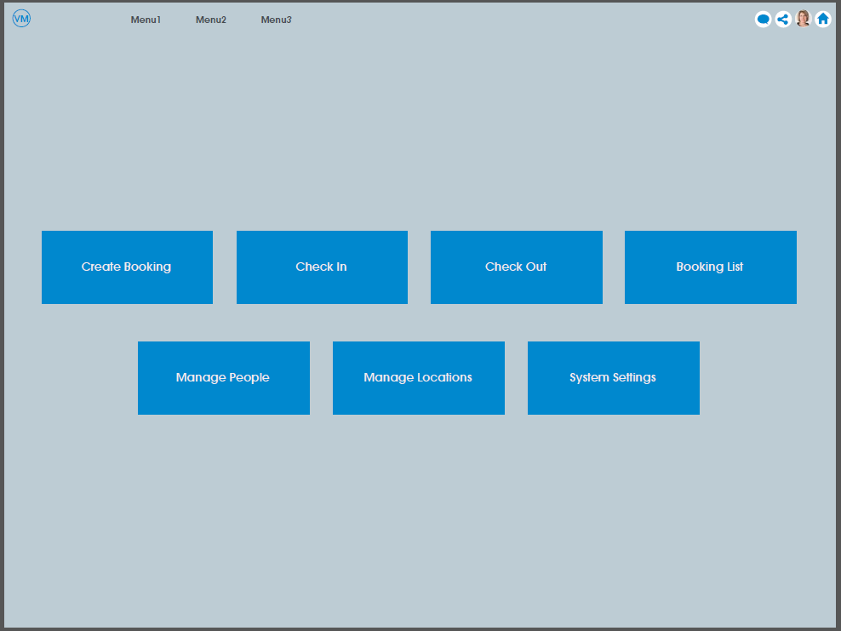

System Settings

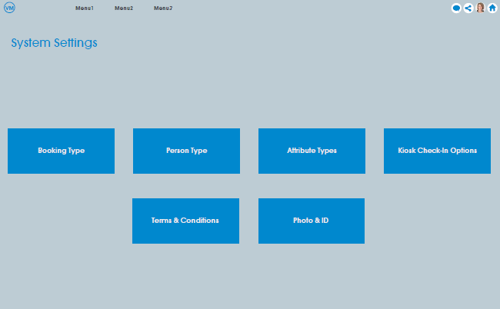

System Settings- Attribute Type

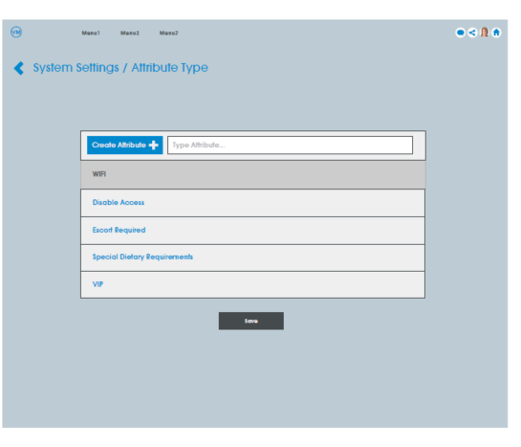

System Settings- Kiosk Check-in Options

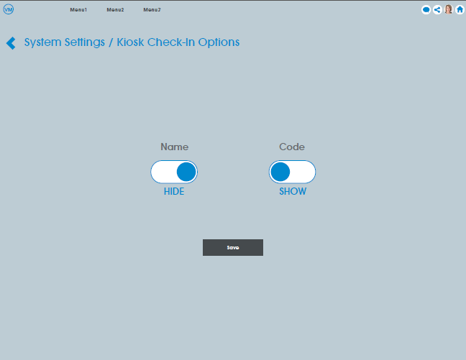

System Settings- Person Type

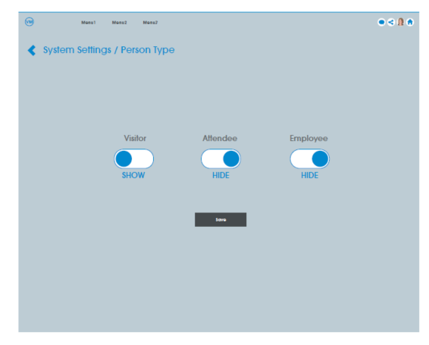

System Settings- Terms and Conditions

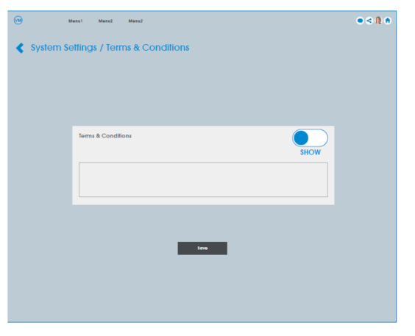

System Settings- Photo ID

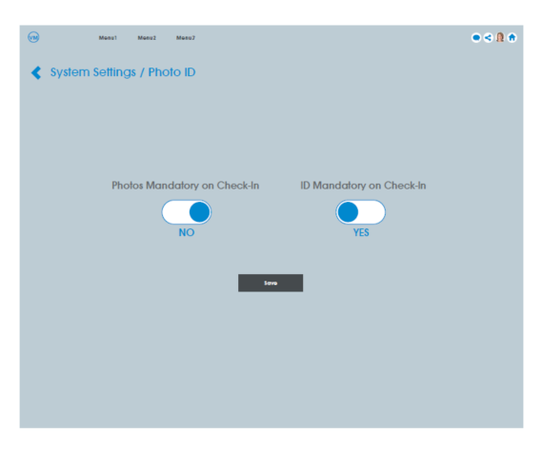

Add Host-additional comments (Selected)

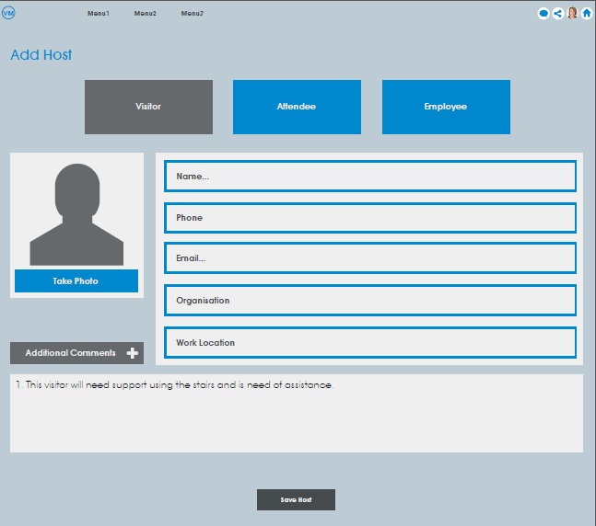

Create New Booking Page:

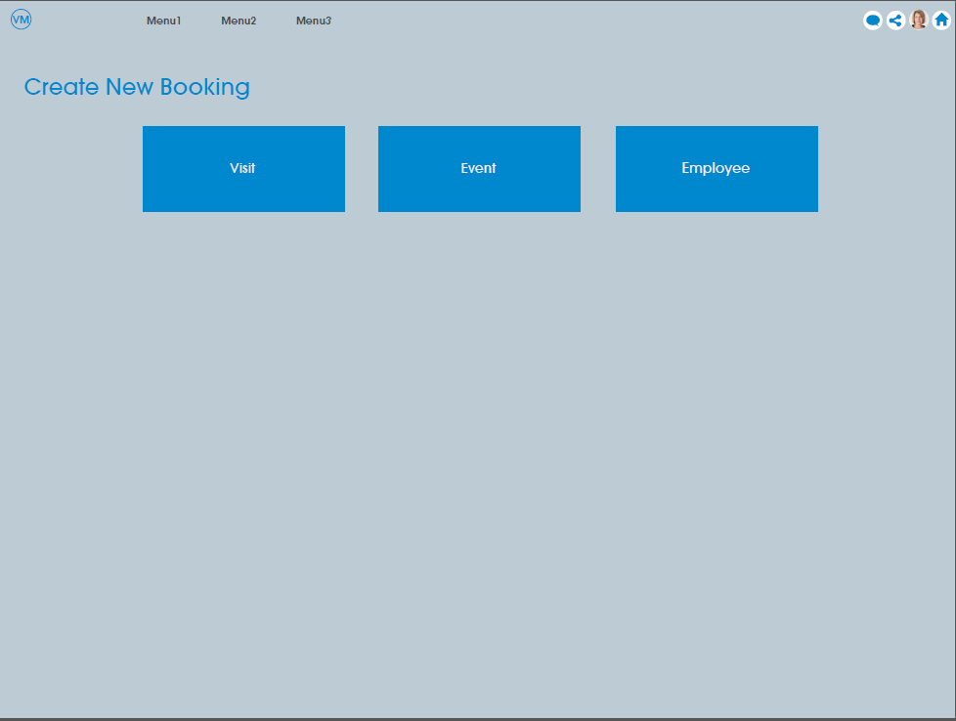

Create New Booking Page- Visit

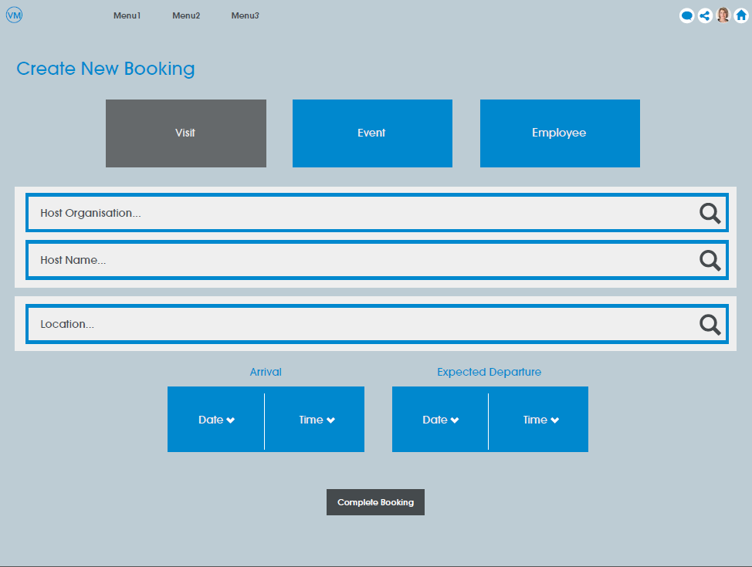

Create New Booking Page- Visit (autocomplete)

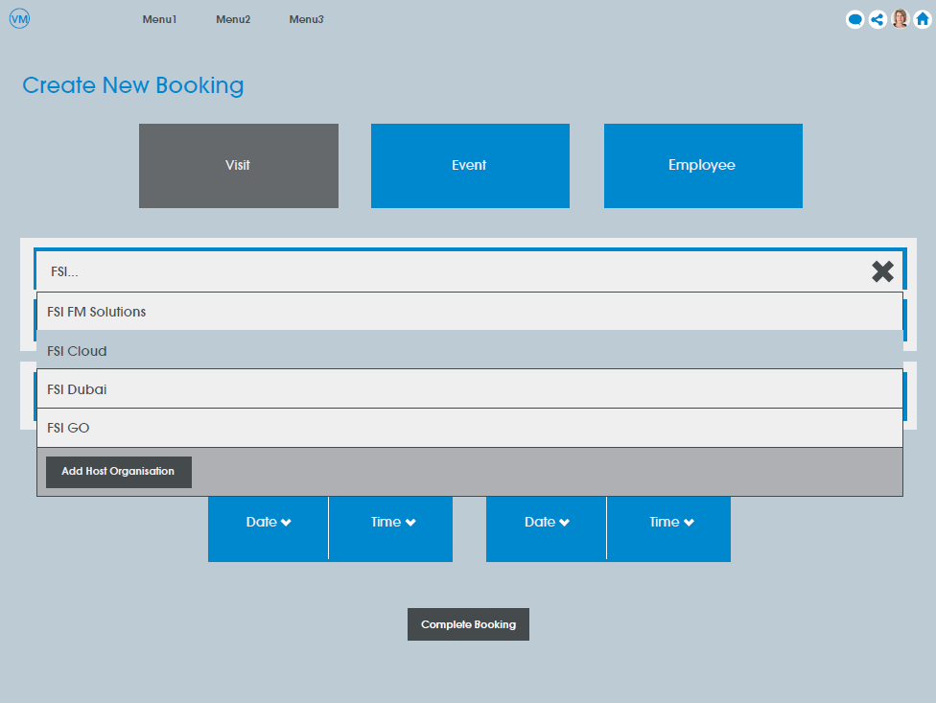

Create New Booking Page- Event

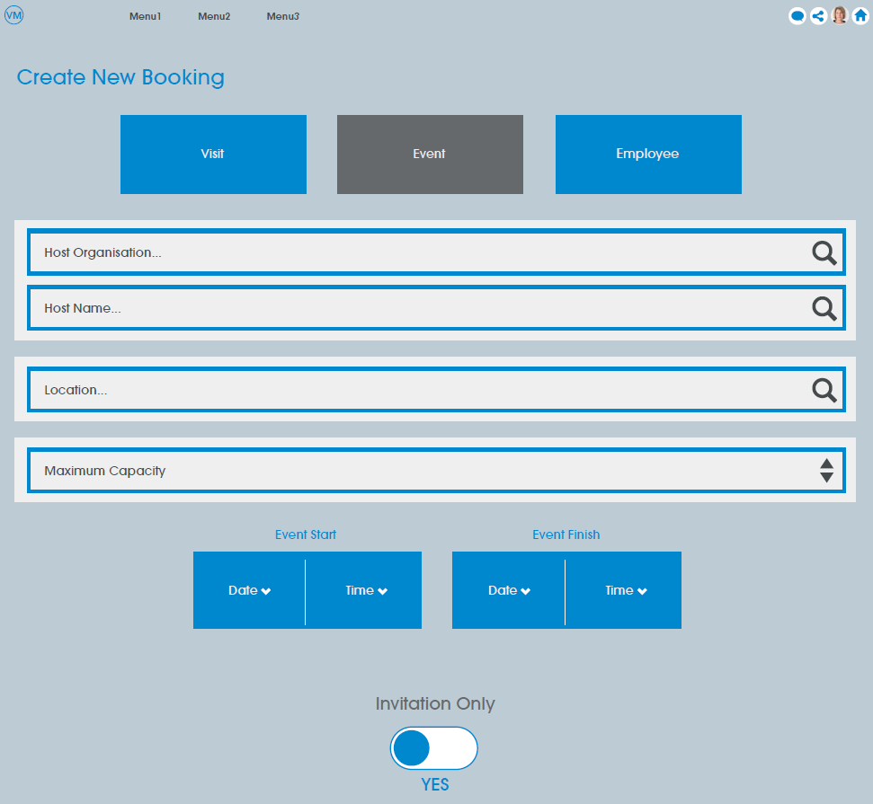

Create New Booking Page- Employee

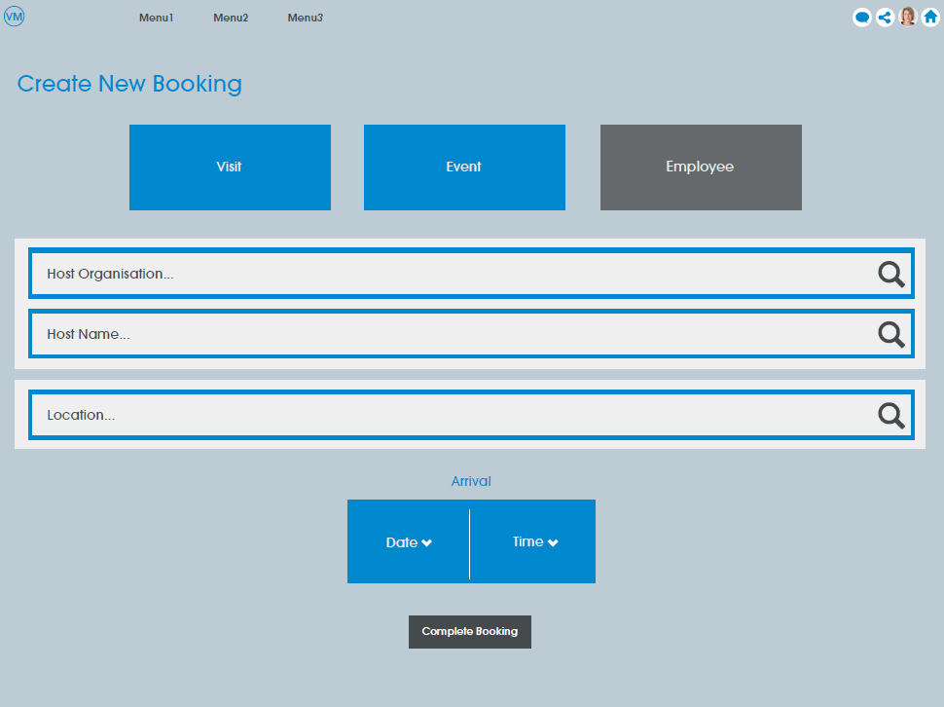

People List

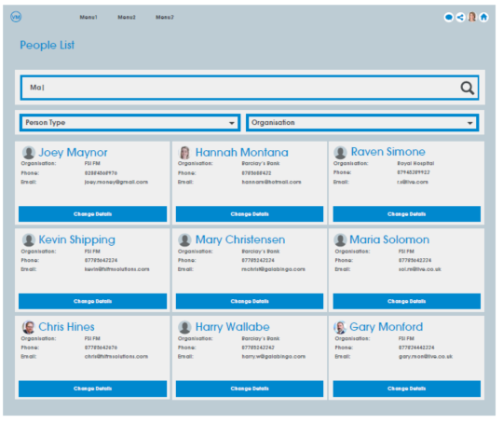

Add Location

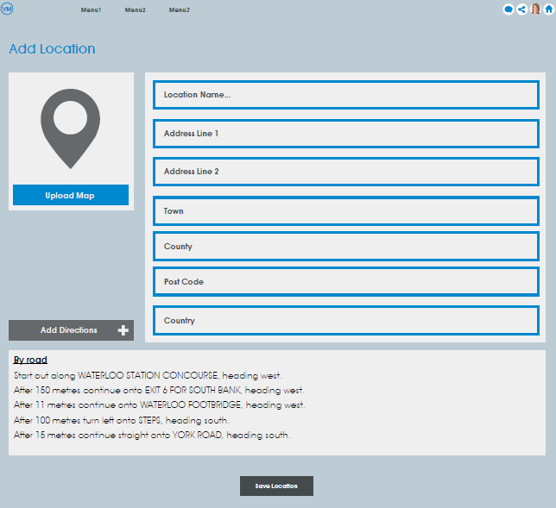

Location List

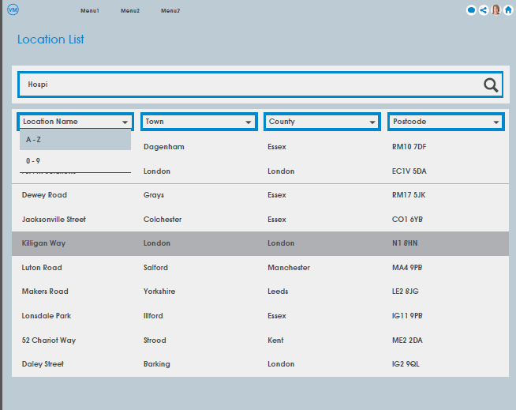

Edit Location

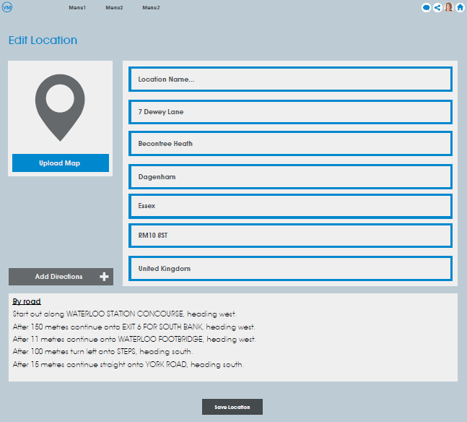

Booking List

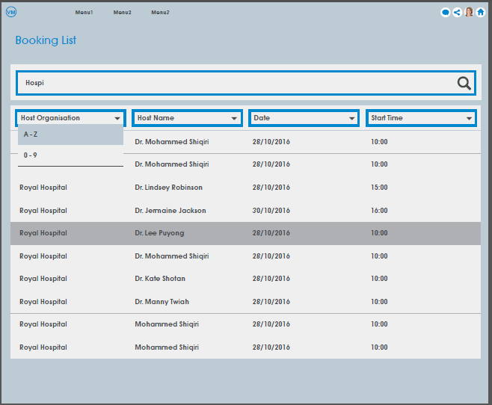

Booking Page- Autocomplete/Add person

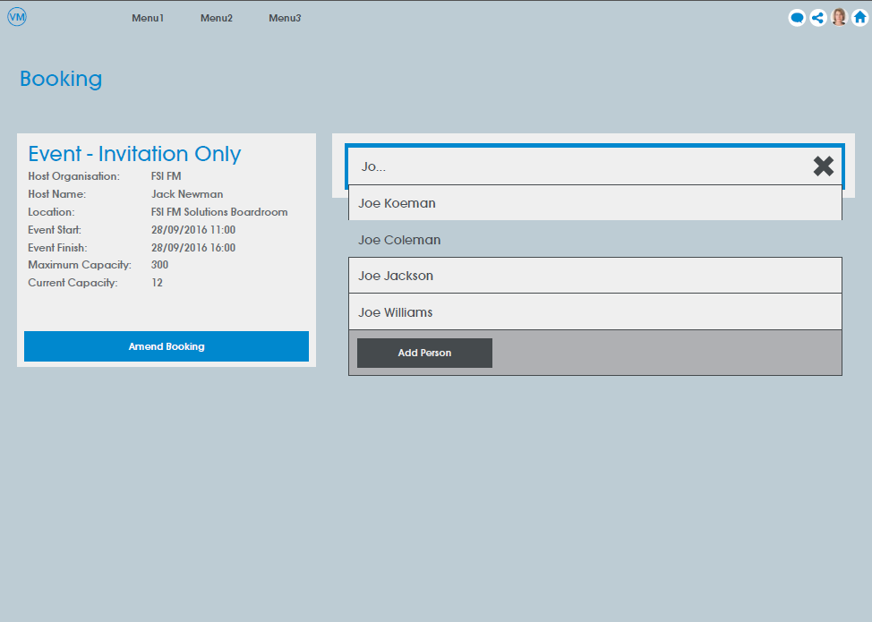

Booking Page- Check-in/Check-out/Remove Attendee

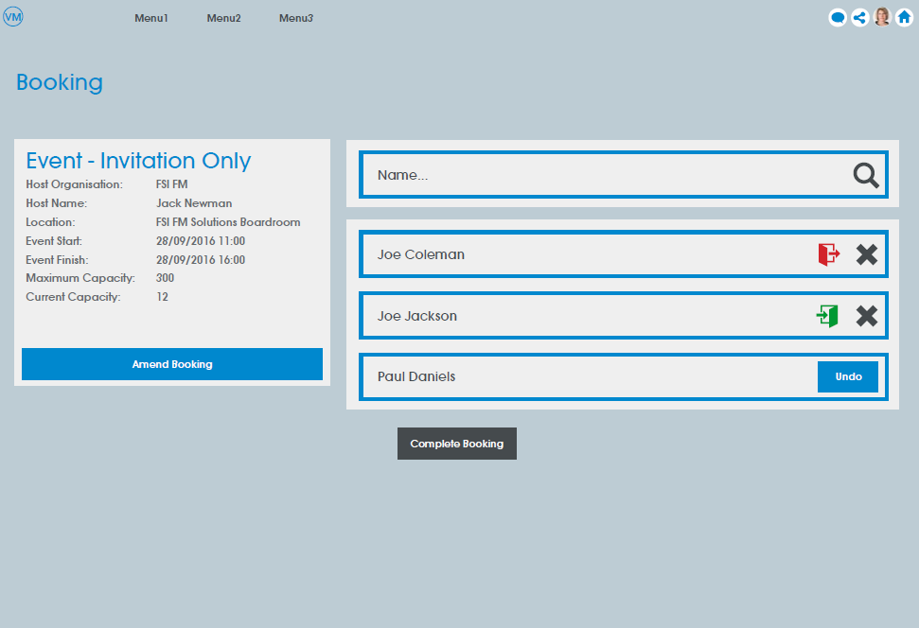

Add Person

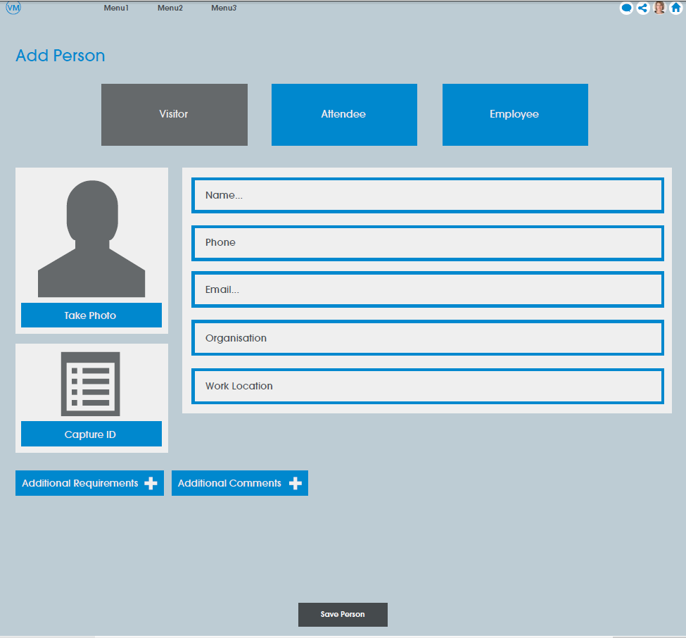

Edit Person

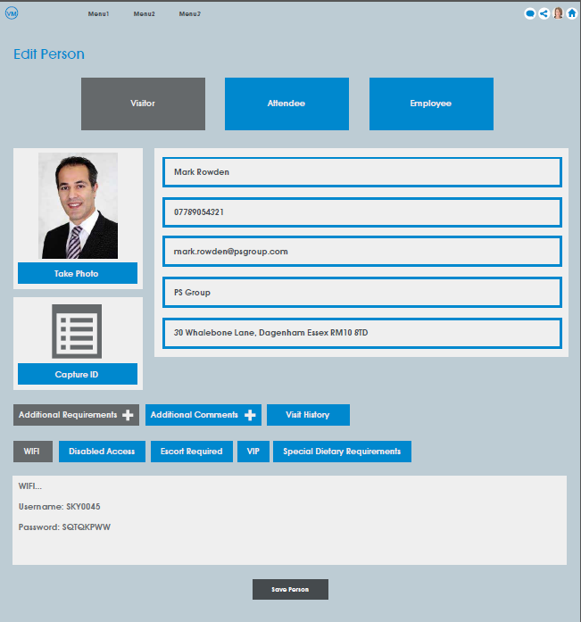

Edit Person-View History

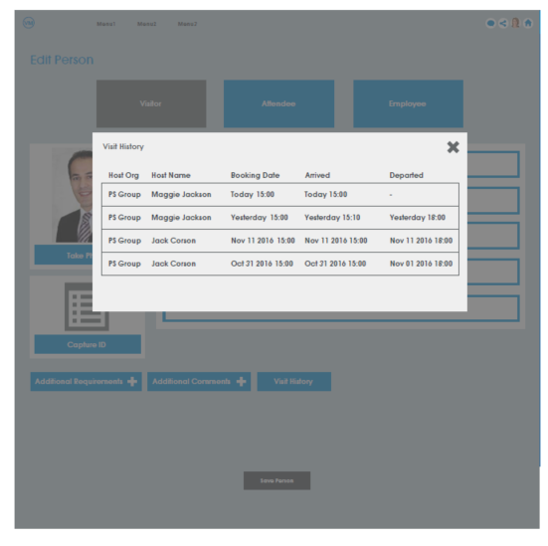

Edit Person- Capture ID

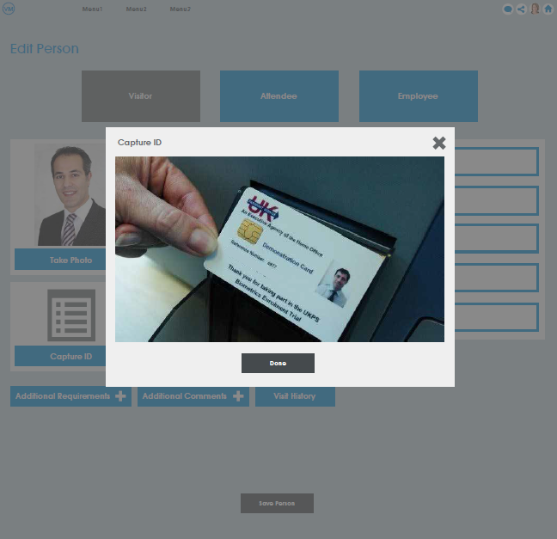

Check-in desk (reception desk)

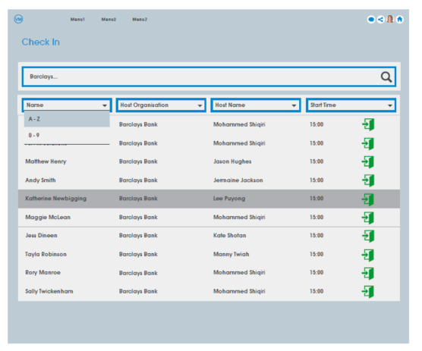

Check-out desk (reception desk)

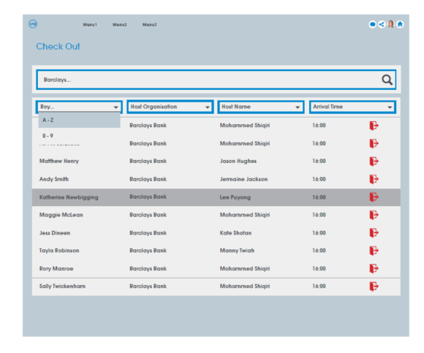

Kiosk- Landing Page

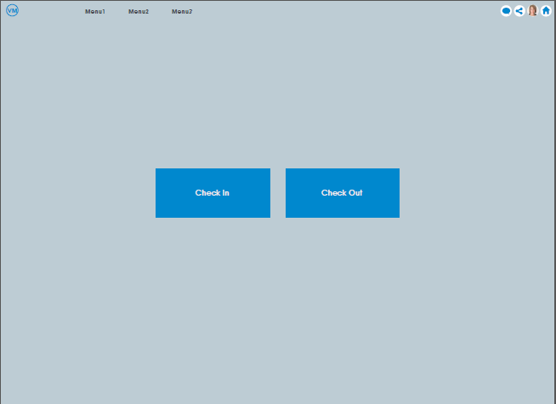

# 4.0 Application wide Specifications

Devices – This application is expected to be used on multiple devices including Desktops, Tablets and Mobiles.

# 5.0 User Journey

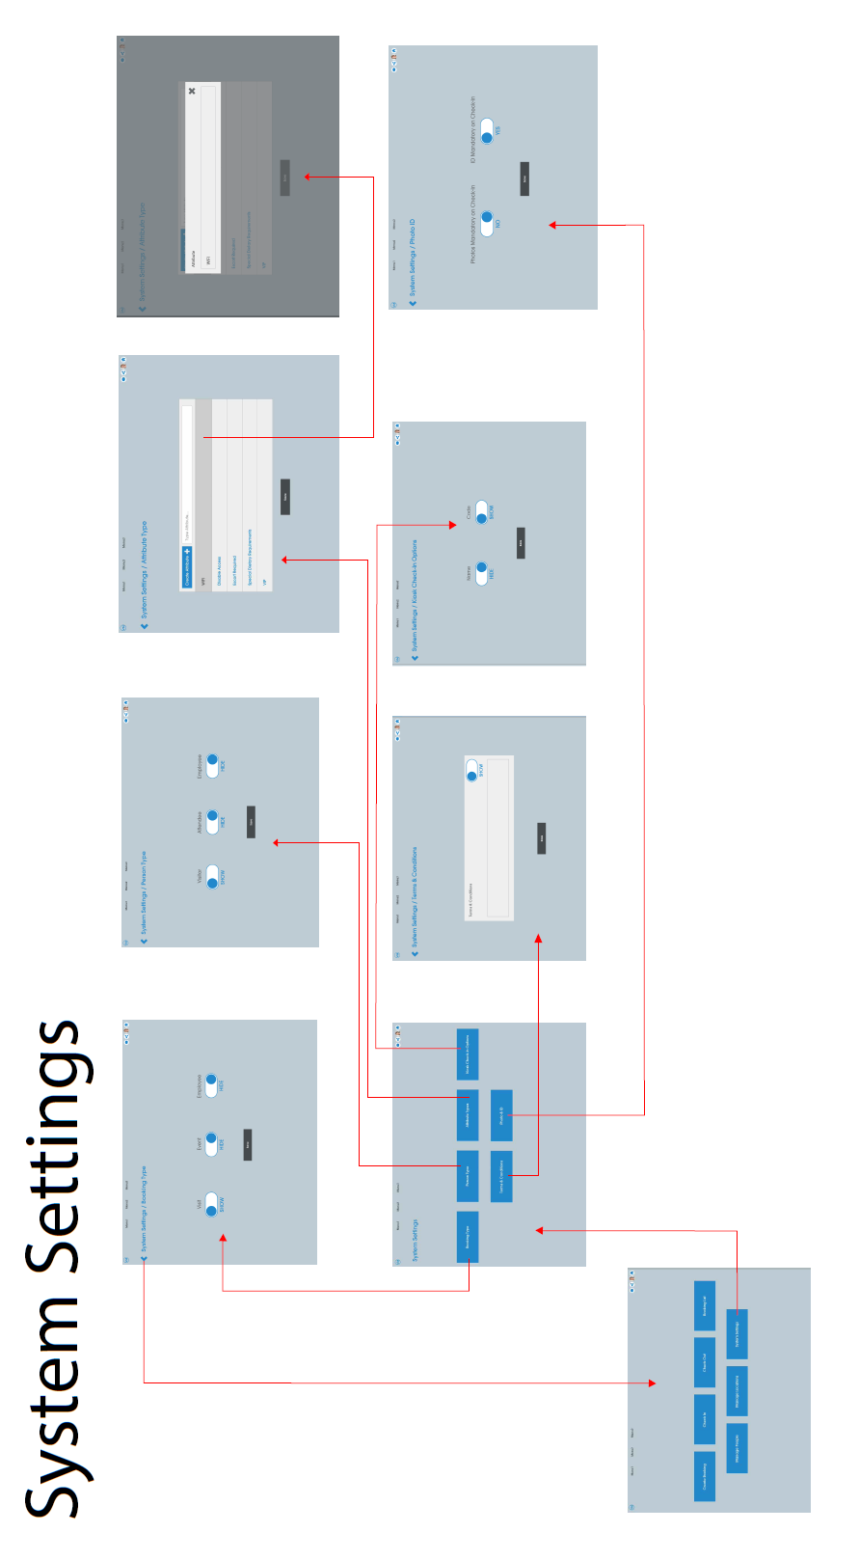

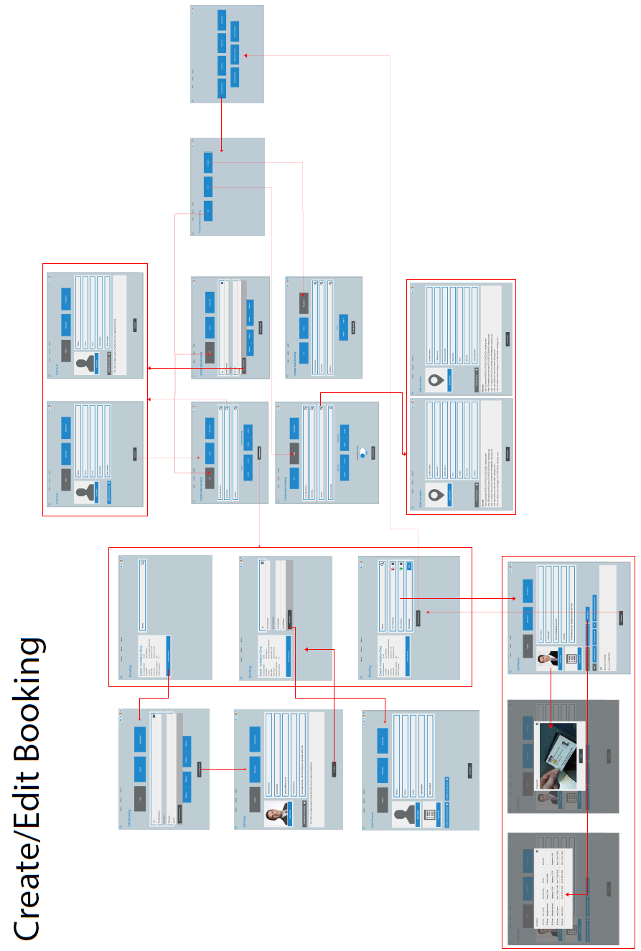

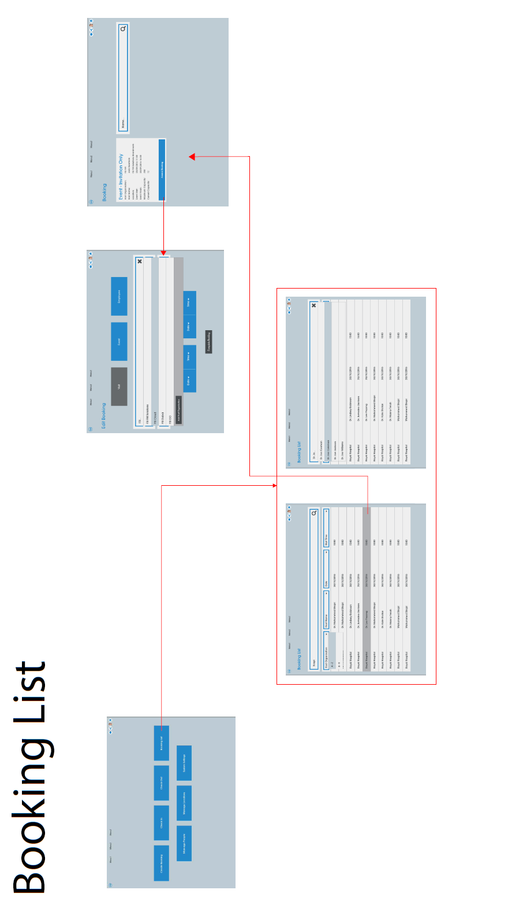

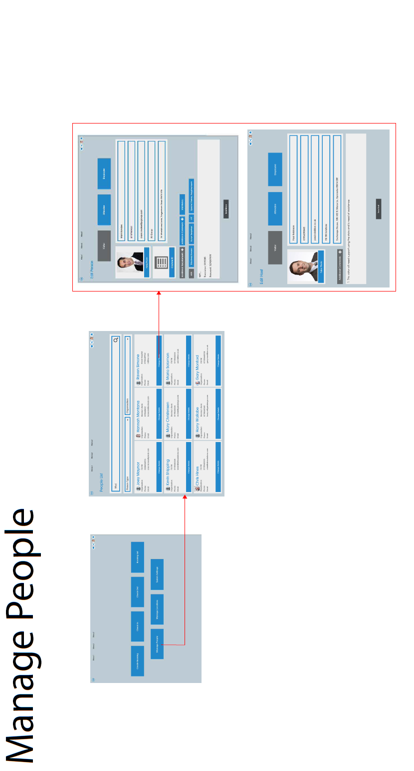

# 

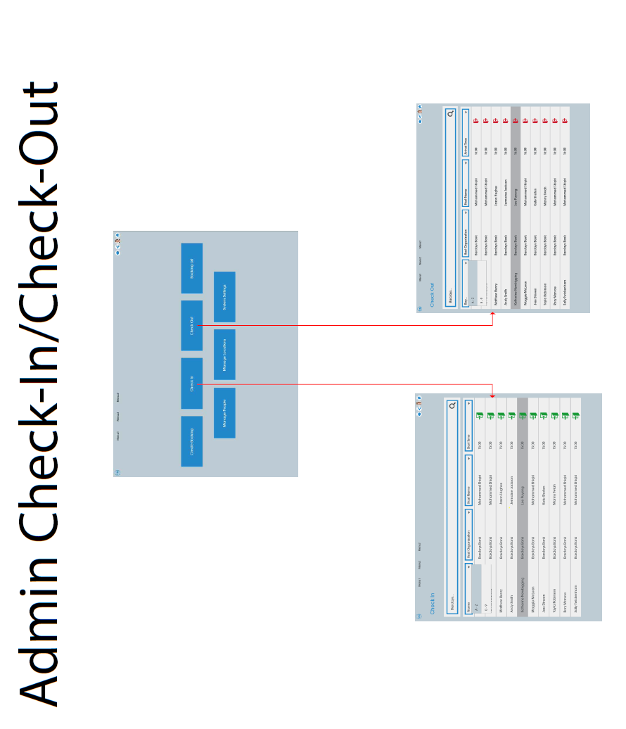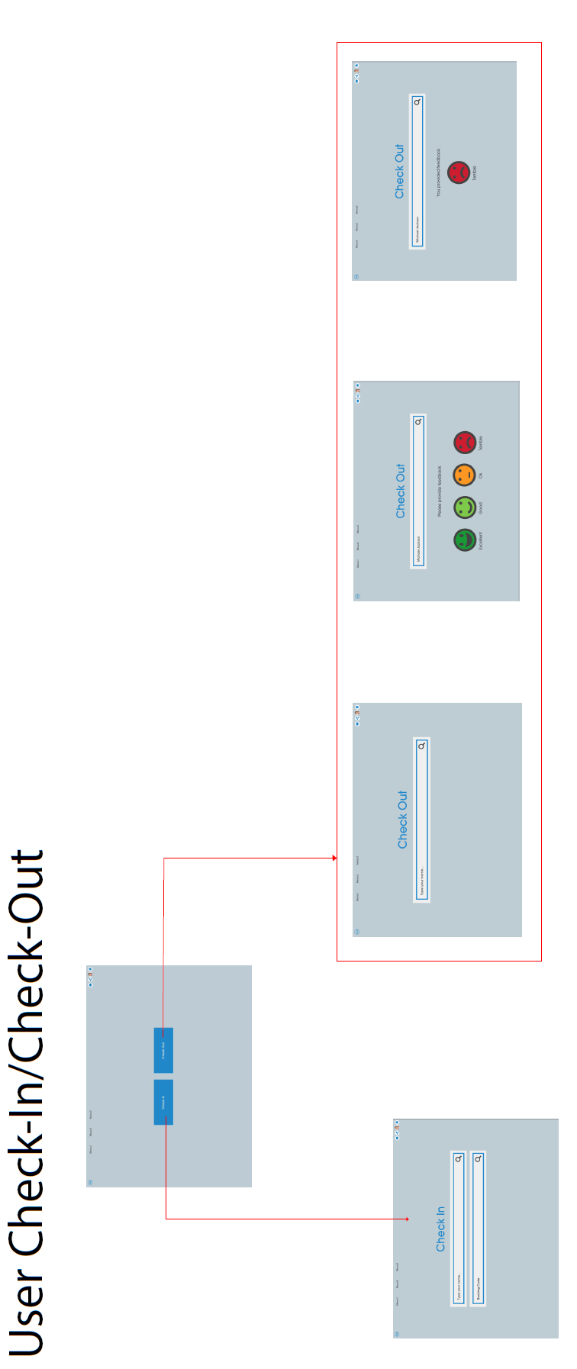

# 6.0 Data Model

**To be included-** A decision was made by EFM team on 17/11/16 that the Technical Lead (Lance Busser) will review current structure provided (available on share point) and update it.

# 7.0 Process Flow

**Available in share point- Visitor Management Process flow version 2.0**

# 7.0 Appendix

**VM: 003- Person Type**

|  |  |
| --- | --- |
| **Person Type** | **Fields** |
| **Visitor / Host** | Name |
|  | Phone |
|  | Email |
|  | Photo (image) |
|  | ID |
|  | Company |
|  | Work Location |
|  |  |
| **Attendee** | Name |
|  | Phone |
|  | Email |
|  | Photo (image) |
|  | ID |
|  | Company |
|  | Work Location |
|  |  |
| **Employee** | Name |
|  | Phone |
|  | Email |
|  | Photo (image) |
|  | Company |
|  | Work Location |
|  |  |

**VM: 004- Booking Type**

|  |  |
| --- | --- |
| **Booking Type** | **Fields** |
| **Visit** | Host Company |
|  | Host |
|  | Location |
|  | Arrival Date |
|  | Arrival Time |
|  | Estimated Departure Date |
|  | Estimated Departure Time |
|  |  |
| **Event** | Host Company |
|  | Host |
|  | Location |
|  | Arrival Date |
|  | Arrival Time |
|  | Estimated Departure Date |
|  | Estimated Departure Time |
|  | Total Capacity |
|  | Current Capacity |
|  |  |
| **Employee** | Host Company |
|  | Host |
|  | Location |
|  | Arrival Date |
|  | Arrival Time |
|  |  |

**VM: 013- Booking Amended / Update**

Dear <Visitor Nam/e>,

Please note the following changes to your upcoming booking:

|  |  |
| --- | --- |
| **Date**  **Time**  **Location** | <Date of Visit> (previously <old date>)  <Time of Visit> (previously <old time>)  <Visit Address> (previously <old address>) |

If you have any queries, please contact <host's phone number> or <host's email>

Kind regards

<Host's name>

NOTE: Only show the relevant previous items in brackets if those items have changed (e.g. don't show previous date if only the time has changed)

**VM: 014 - Booking Cancelled**

Dear <Visitor Name>,

Please note that your upcoming booking has been cancelled:

|  |  |
| --- | --- |
| **Date**  **Time**  **Location**  **Host**  **Cancelled By**  **Reason** | <Date of Visit>  <Time of Visit>  <Visit Address>  <Host Name>  <Cancelled By Name>  <Cancellation Reason> |

If you have any queries, please contact <host's phone number> or <host's email>

Kind regards

<Host's name>

**VM: 021 - Arrival Confirmation**

Dear <Host Name>,

Please note that the following visitor has arrived:

|  |  |
| --- | --- |
| **Name**  **Scheduled Time**  **Arrival Time**  **Arrival Location**  **Contact Details** | <Visitor Name>  <Time of Visit>  <Time of Arrival>  <Check-In Location>  <Visitor Phone Number>  <Visitor Email> |

Kind regards

Visitor Management

**VM: 042b - Booking Confirmation (Event Attendee)**

Dear <Visitor Name>,

Please find below details of your upcoming booking:

**Booking Reference: <Booking Reference>**

|  |  |
| --- | --- |
| **Date**  **Time**  **Host**  **Address**  **Directions**  **Map** | <Date of Visit>  <Time of Visit>  <Host Name>  <Visit Address>  <Directions>  <Map Image> |

If you have any queries, please contact <host's phone number> or <host's email>

Kind regards

<Host's name>

NOTE: Only show the booking reference for event attendees (i.e. these are the ones that will be using a code to arrive via the kiosk)

NOTE: Only show directions if the address associated with the booking has directions stored against it

NOTE: Only embed a map if the address associated with the booking has an image stored against it

**VM: 042a - Booking Confirmation (Visitor)**

Dear <Host Name>,

Please find below confirmation of your booking:

|  |  |
| --- | --- |
| **Date**  **Time**  **Visitor(s)**  **Location** | <Date of Visit>  <Time of Visit>  <Visitor Name>  <Visitor Name>  <Visitor Name>  <Visit Address> |

Kind regards

Visitor Management

**VM: 001 – Print Badge Template**

To be provided by KG (Paul Palmer)